Analyzing E-Learning Platform Purchases using MySQL

Observations
Q1 – Learner Total Spending
- Each learner’s total spending is calculated using quantity × unit_price.
- The learner’s country is displayed along with the total spending.
Q2 – Top 3 Most Purchased Courses
- The courses are ranked based on total quantity sold.
- The top 3 most purchased courses are displayed.
Q3 – Category Revenue
- Total revenue is calculated for each course category.
- The number of unique learners purchasing from each category is also shown.
Q4 – Learners with Multiple Categories
- Learners who purchased courses from more than one category are identified.
Q5 – Unpurchased Courses
- Courses with no purchase records are identified.
- This helps to find courses that have not generated any sales.

SCREENSHOT 1
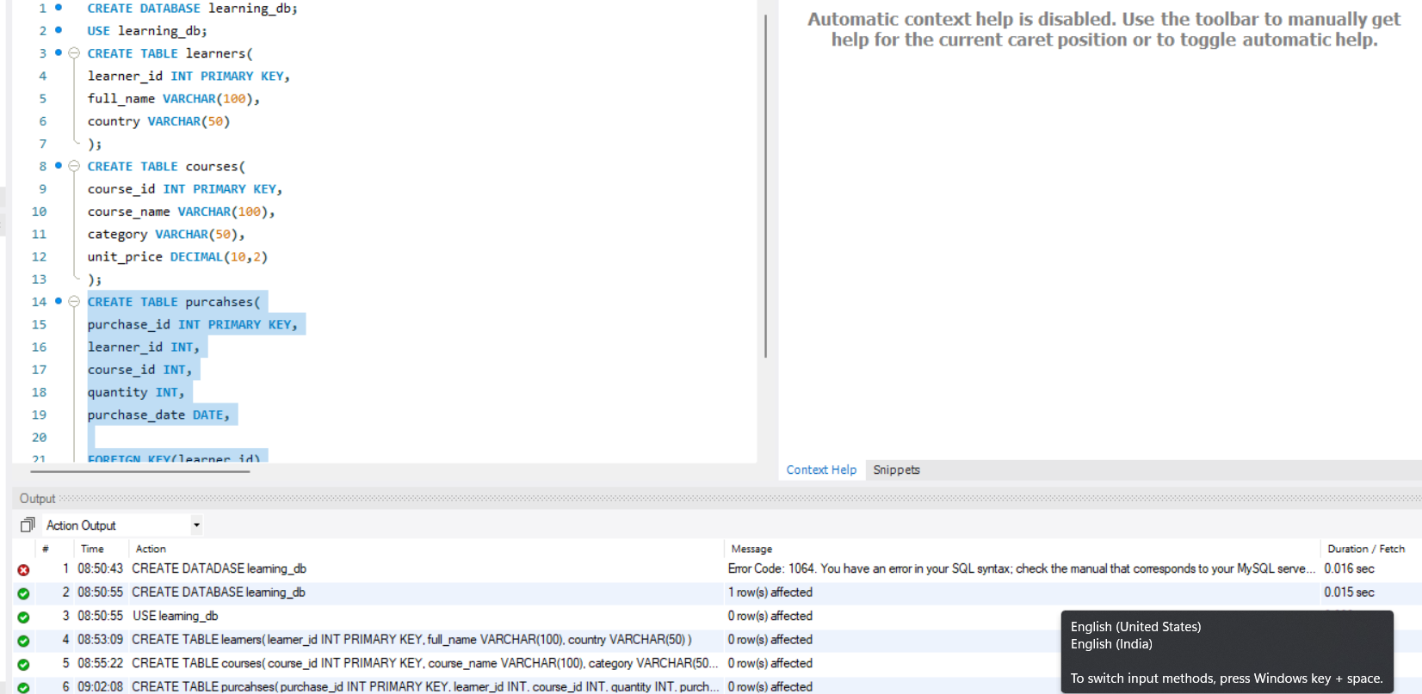

SCREENSHOT 2
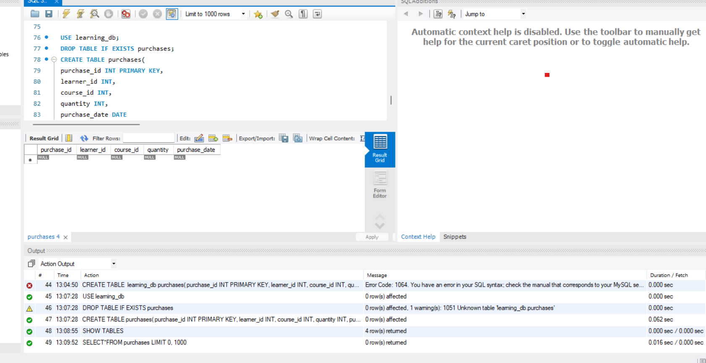
SCREENSHOT 3

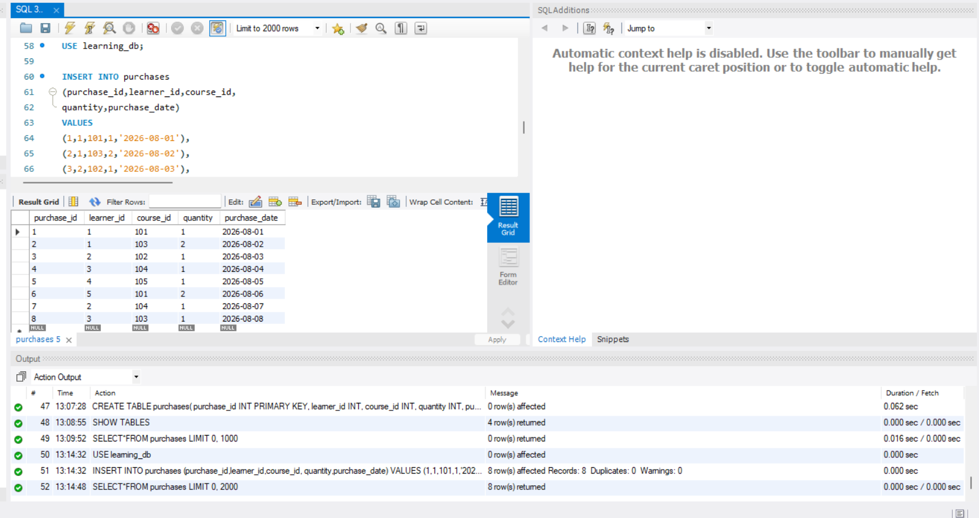

SCREENSHOT 4

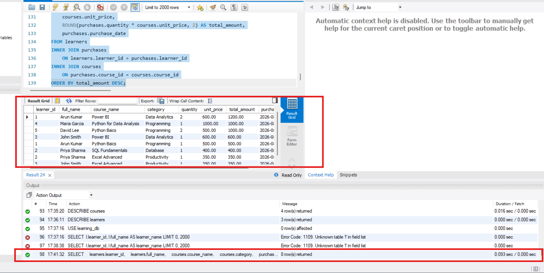
SCREENSHOT 5
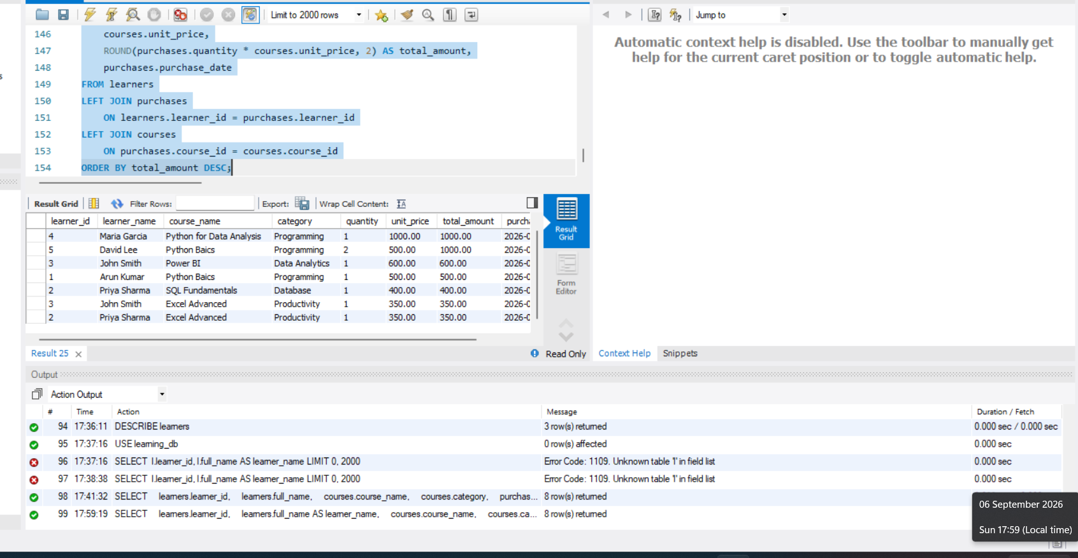
SCREENSHOT 6
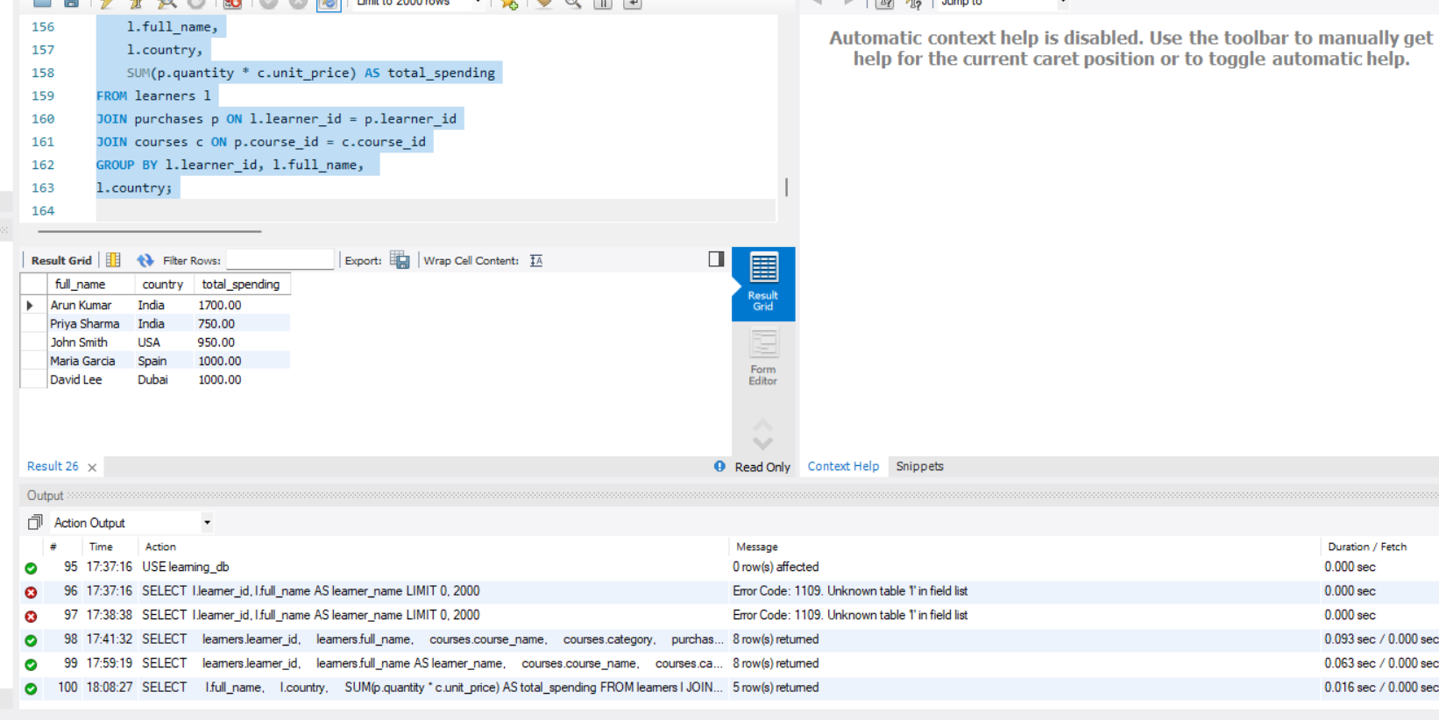

SCREENSHOT 7
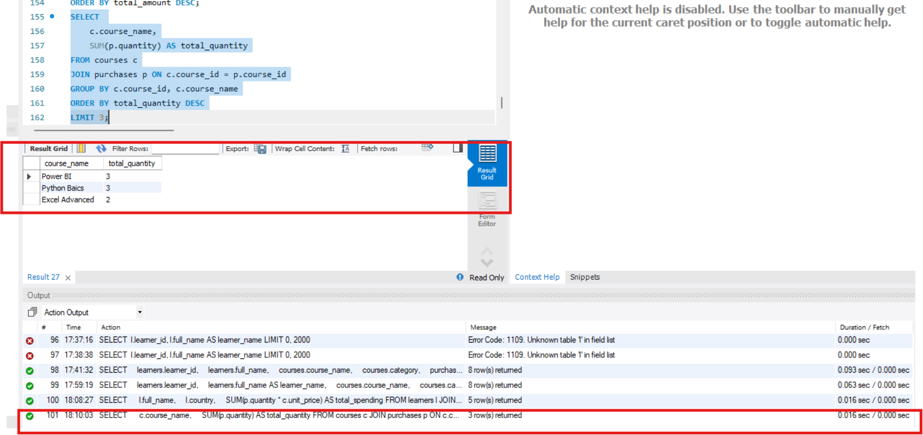

SCREENSHOT 8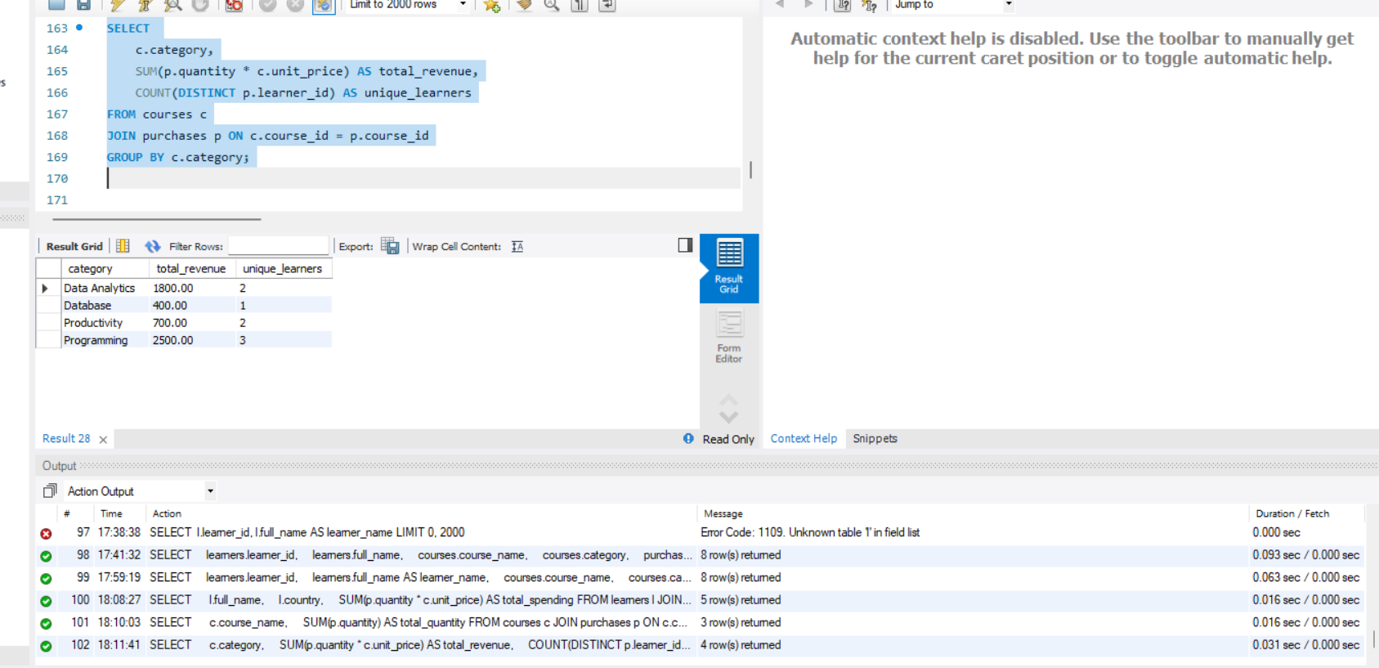

SCREENSHOT 9
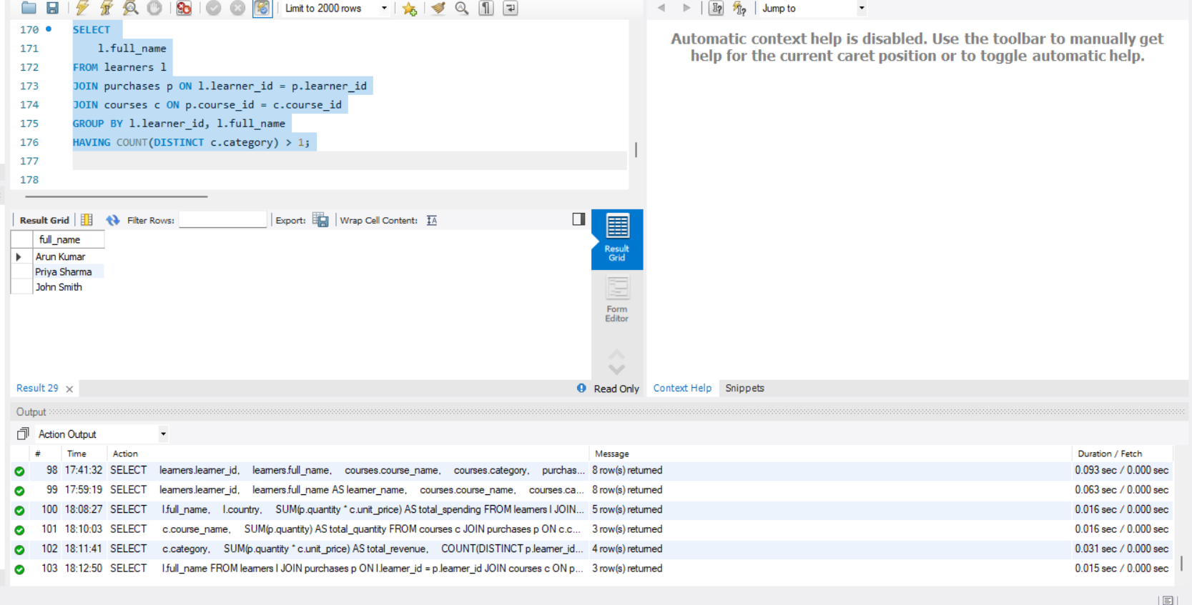

SCREENSHOT 10

